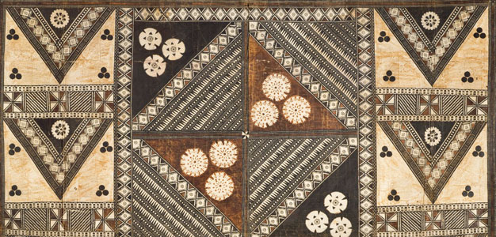
African Art Module

Ikenga (shrine figure). Igbo peoples (Nigeria). c. 19th to 20th century C.E. Wood.
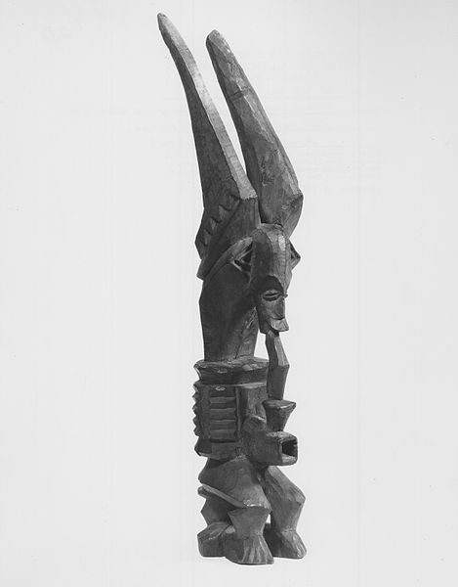

Image Citation: Brooklyn Museum 75.147.2 Ram-Headed Ikenga Figure (4)" by Brooklyn Museum. Licensed under CC BY 3.0 via Wikimedia Commons -

Ikenga (Igbo literal meaning "place of strength") is a horned Alusi (deity) found among the Igbo people in southeastern Nigeria. It is one of the most popular symbols of the Igbo people, and the most common cultural artifact. Ikenga is mostly maintained, kept or owned by men and occasionally by women of high reputation and integrity in the society.
Ikengas are dedicated to the hand, and at that, specifically the right arm. Their belief is that in order to be successful in hunting, farming and warfare, you need strong hands and arms. Sharp horns are the most essential feature of the Igbo and Igala altars to the hand as they are ancient symbols of aggression and ambition. The owner regularly offered prayers and sacrifices of gin, egg, and kola nut to the spirit of the ikenga (Wikipedia).

Citations:
"Ikenga." Wikipedia. Wikimedia Foundation. Web. 2 Mar. 2015. <http://en.wikipedia.org/wiki/Ikenga>.

