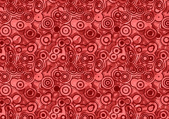
Global Contemporary

Dancing at the Louvre, from the series The French Collection, Part I; #1. Faith
Ringgold. 1991 C.E. Acrylic on canvas, tie-dyed, pieced fabric border
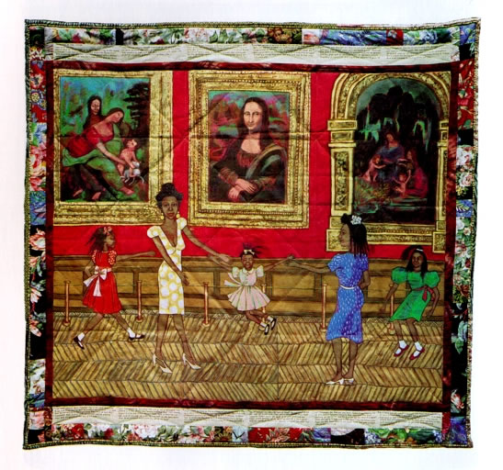

Photo Citation: https://www.khanacademy.org/humanities/global-culture/identity-body/identity-body-united-states/a/ringgold-dancing-at-the-louvre

Marcia and her three little girls took me dancing at the Louvre. I thought I was taking them to see the Mona Lisa. You’ve never seen anything like this. Well, the French hadn’t either. Never mind Leonardo da Vinci and Mona Lisa, Marcia and her three girls were the show. (Willa Marie Simone, Dancing at the Louvre)

Faith Ringgold is known for combining representational painting and African-American quilting techniques with the text in a form called “story quilts.” Dancing at the Louvre is the first in Ringgold’s series of twelve works entitled The French Collection. The series tells a fictional story of a character named Willa Marie Simone. Willa Marie is a young black woman who moves to Paris in the early 20th century. The story is told though the text written around the margin of each quilt. Willa Marie is an artist, model, and cafe owner living in France.Ringgold has referred to Willa Maries as being her alter ego. In this quilt series, Willia Marie visits art sites including the Louvre and Claude Monet's garden in Giverny. Ringgold uses European art and artists as a vehicle for inventing visits to Europe by black female celebrities. These female figures include Sojourner Truth and Zora Neale Hurston. Ringgold also includes family and friends in the quilts as well.
She was greatly influenced by the fabric she worked with at home with her mother, who was a fashion designer. She used fabric in many of her artworks. Her painted story quilts question the line between "high art" and "craft" by combining painting, quilted fabric, and the art of storytelling (Khan).
She worked as an activist for social change for women and blacks, particularly with regard to the American art museum system. Museums often omitted artworks of African-Americans and women from its exhibitions. In Dancing at the Louvre, at the Louvre, the children played under the "masterpieces," not “paying all that much attention.” There is an absence of black people in the European art tradition. Also left out are women artists. The artists and the images presented were almost all white. Ringgold is questioning where this left a serious African-American student or artist( Gillespie Fem).

"I'm rewriting history," Ringgold offered. "The life of African American women artists has been so bleak that if I dealt with it factually, it would be too depressing. So, I decided to rewrite history. I created this woman to be a kind of Josephine Baker, but a painter, who went to Paris and became an artist. I bring into her life the things an artist needs to fully develop. She is kind of my alter ego." (Gillespie)

“Ringgold’s story-quilting technique is important to meaning in her work. She creates the central image using acrylic paint on canvas, reflecting her knowledge of western art history in both style and subject matter, and surrounds it with a patchwork cloth border that includes her hand-written text. She then uses traditional quilting methods to sandwich a layer of batting by stitching the decorative front to the plain cotton backing. (Khan Academy.)”

Citation:

"Khan Academy." Khan Academy. Web. 28 Apr. 2015. <https://www.khanacademy.org/humanities/global-culture/identity-body/identity-body-united-states/a/ringgold-dancing-at-the-louvre>.

"New York Artist Takes Us Dancing at the Louvre." "" by Gillespie, Fern. Web. 28 Apr. 2015. <https://www.questia.com/magazine/1P3-38629032/new-york-artist-takes-us-dancing-at-the-louvre>

