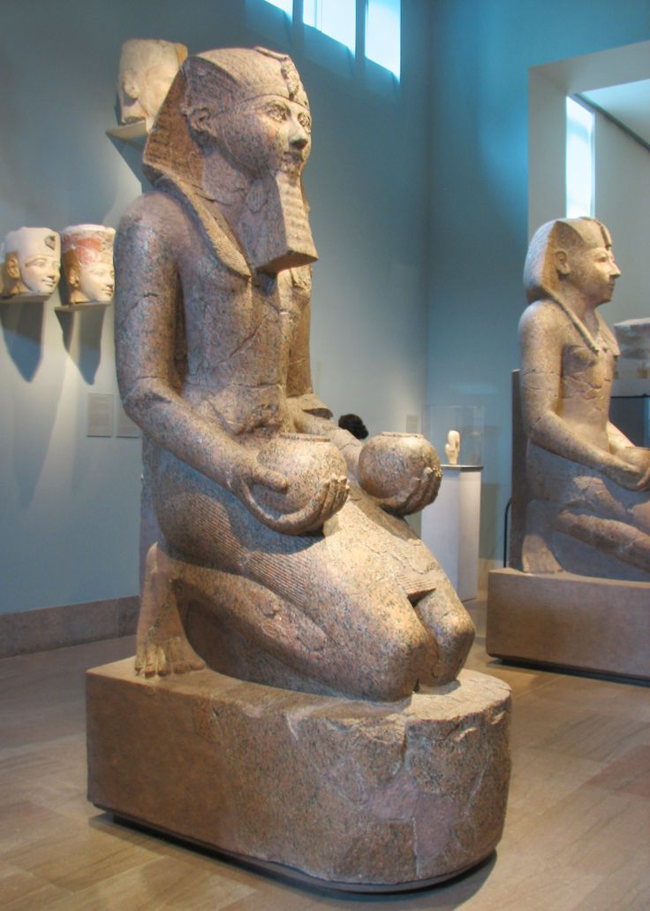

**Content:**  The Statue of Hatshepsut is made in representation of the Egyptian pharaoh Hatshepsut which was the only female pharaoh in ancient Egypt.

**Content:**  Hatshepsut is holding two cups that would hold two liquids water or milk, which most likely represented offerings to the gods.

**Form:** She is depicted as kneeling in the statue, which was common among pharaoh statues in the New Kingdom Era, possibly for placement as a votive figure to pray to the gods.

**Content:** Along the base of the sculpture is an inscription reading “Maatkare”. Maat was the goddess of order, right balance, and justice these were the guiding qualities of her reign.

**Forum:**  Male pharaohs had great power in Egypt so the fact that she was depicted as a male but the fact that she was depicted as a male which was the traditional way shows she possessed immense power.

**Context:**  The statue represents the custom of showing her as a powerful male individual, which is also remarkable because a female can have that power yet she is not depicted as a female.

**Function:** The statue functions as a representation of Hatshepsut in the afterlife that is why she was represented as a male most likely as she probably believed this would give her equal power among male pharaohs in the afterlife.

**Context:**  Hatshepsut is depicted in this piece as a male pharaoh rather than a female. This has significance as it shows that she wanted to be depicted as not an individual but as one of the pharaohs.

**Content:**  The Statue of Hatshepsut was composed of granite in entirety it was also formerly painted however, this rubbed off of the piece over time.

**Context:** The statue itself is found in the upper terrace of the Funerary Temple of Hatshepsut at Deir el Bahri.