Chavín de Huántar. Northern highlands, Peru. Chavín. 900–200 B.C.E. Lanzon Stele and golden nose clip.

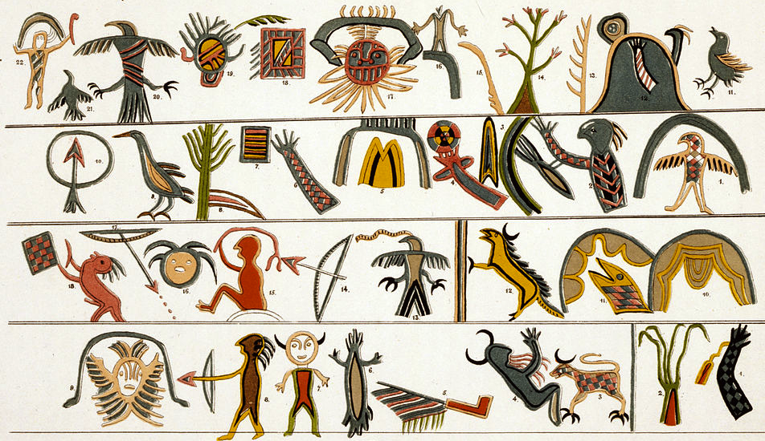
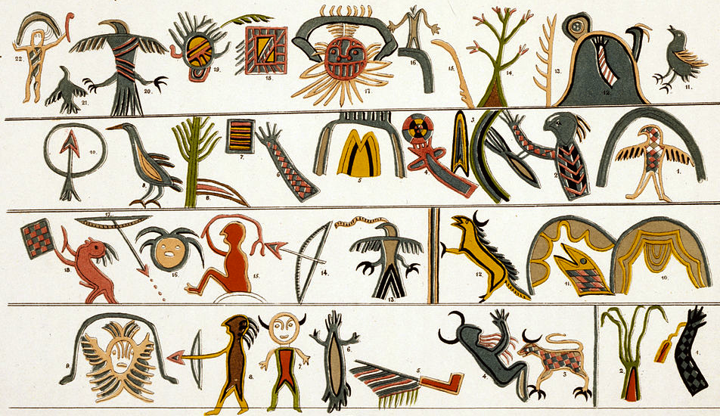
Indigenous Americas Module
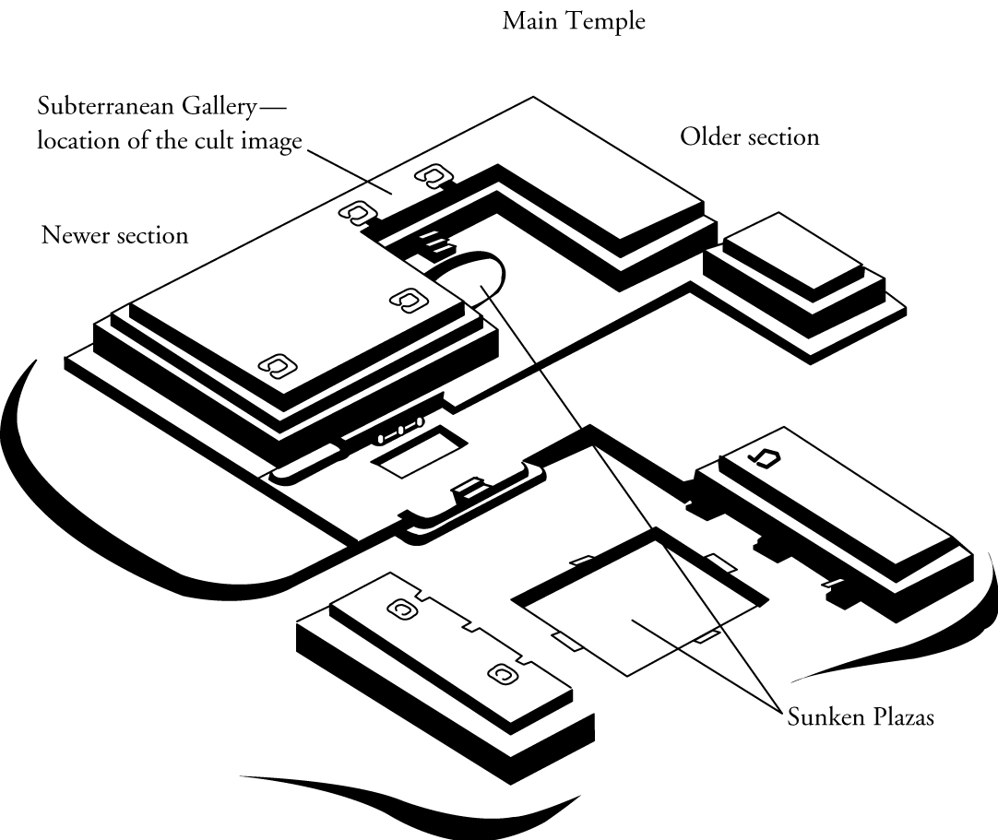
Chavín de Huántar is an archaeological site containing ruins and artifacts constructed ca. 1200 BCE and occupied by later cultures until around 400-500 BCE by the Chavín, a major pre-Inca culture. The site is located 160 miles north of Lima, Peru, at an elevation of 10,000 ft.,
on the edge of the Conchucos Valley. This archaeological site is a large ceremonial center that has revealed a great deal about the Chavín culture. Chavín de Huántar served as a gathering place for people of the region to come together and worship. People went to Chavín de Huántar as a meeting center: to attend and participate in
rituals or consult an oracle (Boundless).
Image Citation: http://schools.nashua.edu/myclass/lavalleev/art%20history%20pictures/ch14/index14.html

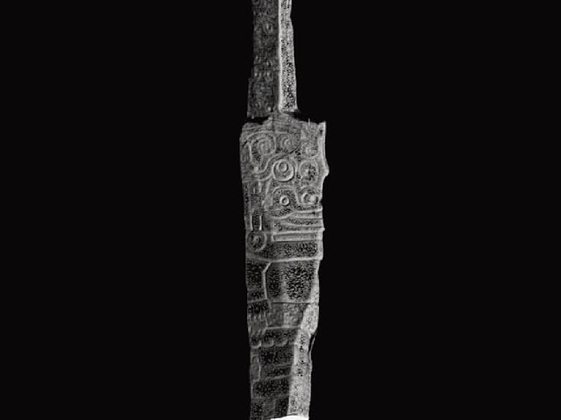

The temple is a massive flat-topped pyramid surrounded by lower platforms. It is a U-shaped plaza with a sunken circular court in the center. The inside of the temple walls are decorated with sculptures and carvings. The Lanzón is the name for the most important statue of the central deity of the Chavín culture. The Lanzón takes its name from the Spanish word for "lance," the shape of the sculpture.
Image Citation: "Chavin lanzon stela cyark" by CyArk - Still image from full video, viewable at CyArk. Licensed under CC BY-SA 3.0 via Wikimedia Commons -
The Lanzón is located in the central cruciform chamber of a labyrinthine series of ßunderground passages in the Old Temple. Worshippers would be led into the maze of dark tunnels, to be presented face to face with the sculpture's snarling mouth and upturned eyes. The worshipers' disorientation, as well as their reaction to the hallucinogenic San Pedro cactus they were given before entering the temple, intensified the visual and psychological impact of the sculpture (Wikipedia).
The 15 foot tall obelisk is a carved piece of white granite in a roughly lance-like shape, and depicts a human-feline hybrid with claws, writhing snakes for hair and eyebrows, fangs curved sideways in a smile. One arm is depicted raised while the other is lowered. The Lanzón projects into a second chamber above, allowing one positioned at its edge to ‘speak’ for the stela; however, most evidence for this was destroyed as a result of the landslide in 1945
Adornment not only represented status, but sacred origin. Gold jewelry allowed the wearer to transform himself into an animal-god personality with special powers.
An important Chavin artifact was the nose ring, or narigurea. These golden nose shields were hammered down to featherweight thinness. The ring on top of the decoration was open, so it would painlessly attach under the nose between the nostrils. It is believed that the size of the nose rings increased as the person advanced in rank (Ethic Jewelry).

Citation:
Boundless. “Chavin de Huantar.” Boundless Art History. Boundless, 03 Jul. 2014. Retrieved 17 Feb. 2015 from https://www.boundless.com/art-history/textbooks/boundless-art-history-textbook/native-american-art-before-1300-16/south-america-111/chavin-de-huantar-491-8330/

"Lanzón." Wikipedia. Wikimedia Foundation. Web. 17 Feb. 2015. <http://en.wikipedia.org/wiki/Lanzón>.

"Nose Rings in Pre-Columbian Civilizations By Barbara Steinberg." Nose Rings in Pre-Columbian Civilizations By Barbara Steinberg. Web. 17 Feb. 2015. <http://ethnicjewelsmagazine.com/nose-rings-in-pre-columbian-civilizations-by-barbara-steinberg/>.

Citations:

