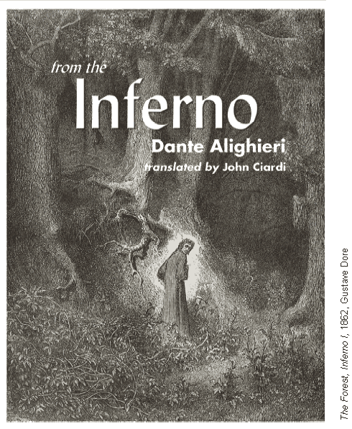

Background
The Divine Comedy is composed of three sections—the Inferno , thePurgatorio , and the Paradiso . In the Inferno , the poet Virgil has been sent by Beatrice to lead Dante through Hell. Hell, a series of downward spiraling circles, is organized according to the gravity of the sin being punished. The lowest circle is reserved for traitors and Lucifer himself, the ultimate betrayer.
In Canto I of the Inferno , Dante first awakens to his plight and meets his guide. In Canto III, Virgil leads Dante through the Gate and into Hell itself.

Canto I
the dark wood of error
Midway in his allotted threescore years and ten, Dante comes to himself with a start and realizes that he has strayed from the True Way into the Dark Wood of Error (Worldliness). As soon as he has realized his loss, Dante lifts his eyes and sees the first light of the sunrise (the Sun is the Symbol of Divine Illumination) lighting the shoulders of a little hill (The Mount of Joy). It is the Easter Season, the time of resurrection, and the sun is in its equinoctial rebirth.1 This juxtaposition of joyous symbols fills Dante with hope and he sets out at once to climb directly up the Mount of Joy, but almost immediately his way is blocked by the Three Beasts of Worldliness: The Leopard of Malice and Fraud, The Lion of Violence and Ambition, and The She-Wolf of Incontinence. 2These beasts, and especially the She-Wolf, drive him back despairing into the darkness of error. But just as all seems lost, a figure appears to him. It is the shade of Virgil, 3 Dante’s symbol of Human Reason.
Virgil explains that he has been sent to lead Dante from error. There can, however, be no direct ascent past the beasts: the man who would escape them must go a longer and harder way. First he must descend through Hell (The Recognition of Sin), then he must ascend through Purgatory (The Renunciation of Sin), and only then may he reach the pinnacle of joy and come to the Light of God. Virgil offers to guide Dante, but only as far as Human Reason can go. Another guide (Beatrice, symbol of Divine Love ) must take over for the final ascent, for Human Reason is self-limited. Dante submits himself joyously to Virgil’s guidance and they move off.
Midway in our life’s journey,4 I went astray
from the straight road and woke to find myself
alone in a dark wood. How shall I say
what wood that was! I never saw so drear,
5so rank, so arduous5 a wilderness!
Its very memory gives a shape to fear.
Death could scarce be more bitter than that place!
But since it came to good, I will recount
all that I found revealed there by God’s grace.
10How I came to it I cannot rightly say,
so drugged and loose with sleep had I become
when I first wandered there from the True Way.
But at the far end of that valley of evil
whose maze had sapped my very heart with fear
15I found myself before a little hill
and lifted up my eyes. Its shoulders glowed
already with the sweet rays of that planet6
whose virtue leads men straight on every road,
and the shining strengthened me against the fright
20whose agony had wracked the lake of my heart
through all the terrors of that piteous night.
Just as a swimmer, who with his last breath
flounders ashore from perilous seas, might turn
to memorize the wide water of his death—
25so did I turn, my soul still fugitive
from death’s surviving image, to stare down
that pass that none had ever left alive.
And there I lay to rest from my heart’s race
till calm and breath returned to me. Then rose
30and pushed up that dead slope at such a pace
each footfall rose above the last. And lo!
almost at the beginning of the rise
I faced a spotted Leopard,7 all tremor and flow
and gaudy pelt. And it would not pass, but stood
35so blocking my every turn that time and again
I was on the verge of turning back to the wood.
This fell at the first widening of the dawn
as the sun climbing Aries with those stars
that rode with him to light the new creation.8
40Thus the holy hour and the sweet season
of commemoration did much to arm my fear
of that bright murderous beast with their good omen.
Yet not so much but what I shook with dread
at sight of a great Lion that broke upon me
45raging with hunger, its enormous head
held high as if to strike a mortal terror
into the very air. And down his track,
a She-Wolf drove upon me, a starved horror
ravening and wasted beyond all belief.
50She seemed a rack for avarice,9 gaunt and craving.
Oh many the souls she has brought to endless grief!
She brought such heaviness upon my spirit
at sight of her savagery and desperation,
I died from every hope of that high summit.
55And like a miser—eager in acquisition
but desperate in self-reproach when Fortune’s wheel
turns to the hour of his loss—all tears and attrition10
I wavered back; and still the beast pursued,
forcing herself against me bit by bit
60till I slid back into the sunless wood.
And as I fell to my soul’s ruin, a presence
gathered before me on the discolored air,
the figure of one who seemed hoarse from long silence.
At sight of him in that friendless waste I cried:
65“Have pity on me, whatever thing you are,
whether shade or living man.” And it replied:
“Not man, though man I once was, and my blood
was Lombard, both my parents Mantuan.11
I was born, though late, sub Julio, 12 and bred
70in Rome under Augustus in the noon
of the false and lying gods.13 I was a poet
and sang of old Anchises’ noble son
who came to Rome after the burning of Troy.14
But you—why do you return to these distresses
75instead of climbing that shining Mount of Joy
which is the seat and first cause of man’s bliss?”
“And are you then that Virgil and that fountain
of purest speech?” My voice grew tremulous :
“Glory and light of poets! now may that zeal
80and love’s apprenticeship that I poured out
on your heroic verses serve me well!
For you are my true master and first author,
the sole maker from whom I drew the breath
of that sweet style whose measures have brought me honor.
85See there, immortal sage, the beast I flee.
For my soul’s salvation, I beg you, guard me from her,
for she has struck a mortal tremor through me.”
And he replied, seeing my soul in tears:
“He must go by another way who would escape
90this wilderness, for that mad beast that fleers15
before you there, suffers no man to pass.
She tracks down all, kills all, and knows no glut,
but, feeding, she grows hungrier than she was.
She mates with any beast, and will mate with more
95before the Greyhound comes to hunt her down.
He will not feed on lands nor loot, but honor
and love and wisdom will make straight his way.
He will rise between Feltro and Feltro,16 and in him
shall be the resurrection and new day
100of that sad Italy for which Nisus died,
and Turnus, and Euryalus, and the maid Camilla.17
He shall hunt her through every nation of sick pride
till she is driven back forever to Hell
whence Envy first released her on the world.
105Therefore, for your own good, I think it well
you follow me and I will be your guide
and lead you forth through an eternal place.
There you shall see the ancient spirits tried
in endless pain, and hear their lamentation
110as each bemoans the second death18 of souls.
Next you shall see upon a burning mountain19
souls in fire and yet content in fire,
knowing that whensoever it may be
they yet will mount into the blessed choir.
115To which, if it is still your wish to climb,
a worthier spirit20 shall be sent to guide you.
With her shall I leave you, for the King of Time,
who reigns on high, forbids me to come there21
since, living, I rebelled against his law.
120He rules the waters and the land and air
and there holds court, his city and his throne.
Oh blessed are they he chooses!” And I to him:
“Poet, by that God to you unknown,
lead me this way. Beyond this present ill
125and worse to dread, lead me to Peter’s gate22
and be my guide through the sad halls of Hell.”
And he then: “Follow.” And he moved ahead
in silence, and I followed where he led.

Critical Reading
1. Respond: Which part of Dante’s experience in the Dark Wood did you find most frightening? Explain.
2. (a) Recall: Which three beasts block Dante’s path? (b) Interpret: What emotion or idea does each beast represent? (c) Analyze: Why is each beast an appropriate choice for the emotion or idea it represents?
3. (a) Recall: Who rescues Dante? (b) Infer: What does the authors choice of rescuer and guide reveal about Dantes values?
4. (a) Interpret: Identify at least two lines in Canto I that reveal strong emotion in Dante. (b) Analyze: Based on his thoughts, emotions, and actions thus far, how would you describe Dantes character? (c) Speculate:Based on your understanding of his character, how do you think Dante will respond to the sights and sounds of Hell? Explain.
5. Evaluate: Does Dante the character seem like a real man on a real journey, or does the whole situation presented in Canto I seem like a fantasy? Explain.

