Book of the Dead Spell 125: Weighing of the Heart of the Dead
Chapter 125 is famous in modern studies of ancient Egypt for its tabulated denials of wrongdoing (the 'Negative Confession'), and for the illustration that generally accompanies the composition, depicting the weighing of the heart of the dead individual in the presence of the god Osiris, ruler of the dead. Most manuscripts include an address to Osiris, in which the deceased declares innocence of a series of sins, on arrival at the broad court of the Two Goddesses of What is Right.
There are no written sources earlier than the New Kingdom. Later temple oaths are modelled on the same lines, and it is possible that the denial of sins in this manner derives from a ritual of taking an oath of purity before entering temple service.
The version below comes from the Book of the Dead of Nu, on a papyrus now preserved in the British Museum. The letter N alone stands for the name of the individual, written out in full in the original manuscripts.
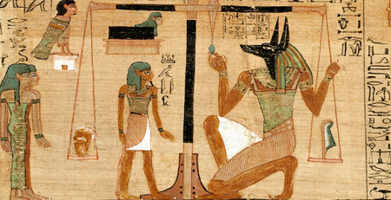

Address at arrival at the broad hall of the Two Goddesses of What is Right, shielding N from all forbidden things that he has done, and seeing the faces of the gods.
Words spoken by N:
Hail great god, lord of the place of the Two Goddesses of What is Right.
I have come before you so that you may bring me to see your perfection.
I know you, I know your name,
I know the name of these 42 gods who are with you in this broad court of the Two Goddesses of What is Right, who live on the henchmen of evil, and eat of their blood on that day of calculating characters in the presence of Wennefer.
See, your name is He of the two Daughters, he of the two Chants, lord of the Two Goddesses of What is Right,
See, I am come before you, I have brought What is Right to you, I have removed What is Wrong for you.
I have not impoverished the divine herd (people); I have committed no crime in place of What is Right;
I have not known (explored) nothingness; I have not done any evil
I have not made a daily start in labours over what I did (previously);
My name has not reached the office of director of servants;
I have not orphaned the orphan of his goods;
I have not done the abomination of the gods;
I have not slighted a servant to his master;
I have not caused affliction; I have not caused hunger; I have not caused grief; I have not killed;
I have not harmed the offering-cattle; I have not caused pain for anyone;
I have not reduced the offerings in the temples;
I have not harmed the offering-loaves of the gods;
I have not taken the festival-loaves of the blessed dead;
I have not reduced the measuring-vessel, I have not reduced the measuring cord;
I have not encroached on the fields; I have not added to the pan of the scales;
I have not tampered with the plumb bob of the scales;
I have not taken milk from the mouths of babes;
I have not concealed herds from their pastures;
I have not snared birds in the thickets of the gods;
I have not caught fish in their pools;
I have not held back water in its time;
I have not dammed a dam at rapid waters;
I have not put out the fire in its moment;
I have not transgressed the days concerning meat offerings;
I have not turned back cattle from the property of a god;
I have not blocked a god in his processions;
I am pure (four times),
my purity is the purity of that great phoenix which is in Henenesut,
because I am indeed that nose of the lord of breath,
who enables all the populace to live, on that day of filling the Sound Eye in Iunu, on month 2 of winter, last day.
I am the one who sees the filling of the Sound Eye in Iunu.
Nothing evil can befall me in this land, in this broad hall of the Two Goddesses of What is Right,
because I know the names of the gods who dwell in it.

