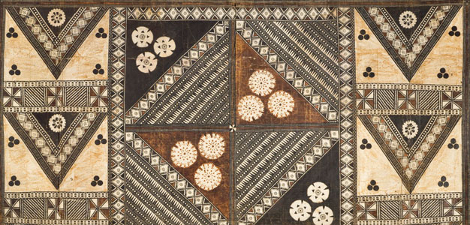
African Art Module

Wall plaque, from Oba’s palace. Edo peoples, Benin (Nigeria). 16th century C.E.
Cast brass

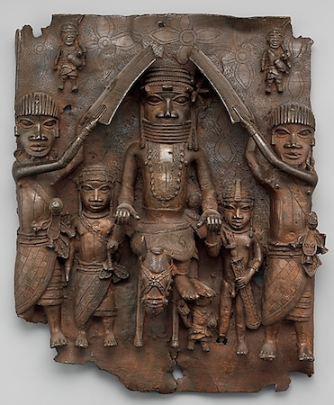

Image Citation: https://www.khanacademy.org/humanities/art-africa-oceania-americas/africa-art/benin/a/benin-plaque-equestrian-oba-and-attendants

“The king’s court is square… and is certainly as large as the town of Haarlem, and entirely surrounded by a special wall, like that which encircles the town. It is divided into many palaces, houses, and apartments of the courtiers, and comprises beautiful and long square galleries, about as large as the Exchange at Amsterdam, but one larger than another, resting on wooden pillars, from top to bottom covered with cast copper, on which are engraved the pictures of their war exploits and battles, and are kept very clean.”
1668 by Olfert Dapper

In the sixteenth and seventeenth centuries a remarkable series of rectangular brass plaques were cast in relief created to hang in the royal palace in Benin. The remarkable series of works were created to adorn the exterior of the royal palace in Benin City.
Edo metal smiths were casting brass before the late fifteenth century when the Portuguese, the first European visitors to the area, arrived bringing copper, a material valued by the Edo peoples. The Portuguese explorer Duarte Pacheco Pereira noted in the 1490s that the Kingdom of Beny “is about eighty leagues long and forty wide; it is usually at war with its neighbors and takes captives, whom we buy at twelve or fifteen brass bracelets each, or for copper bracelets, which they prize more.” The brass casters’ guild melted down the copper bracelets and over time cast plaques, equestrian figures and other statuary, portrait heads of rulers, pitchers in the form of leopards, boxes, and game boards (Museum.dma).
The artist of this work was more concerned with conveying the status of the king and his attendants than in capturing individual physical features. Hierarchical scale is evident as the greatest authority and rank, the warrior chief, in the center, flanked on either side by soldiers of lesser rank. Regalia and symbols of status are emphasized. For example, the warrior is shown with leopard-spot scarification marks and a leopard-tooth necklace. The leopard gives the chief the attributes of stealth, speed, and ferocity. The warrior chief wears a coral-studded helmet and collar. Coral neck rings were a symbol of nobility, and specifically the Oba granted use.
Two attendants, as well as representations of longhaired Europeans which are shown either side of his head, accompany him. Showing the ruler flanked by two attendants is a typical Benin composition. One interpretation of it is as a reminder of the heavy burden of kingship. The attendants are perhaps holding his hands as a symbol of the responsibility of the people to assist their ruler. The attendants who have raised their shields over the Oba may be protecting him from the sun or may be participating in a military ceremony (“Benin Plaque”).

Citations:
Web. 1 Mar. 2015. <http://museum.dma.org:9090/emuseum/view/objects/asitem/2031/129/title-desc?t:state:flow=4c476c4c-8765-4a7d-9c6a-54136e28234b>.

"Benin Plaque: The Oba with Europeans." British Museum. Web. 1 Mar. 2015. <http://www.britishmuseum.org/explore/highlights/highlight_objects/aoa/b/benin_plaque_oba__europeans.aspx>.

