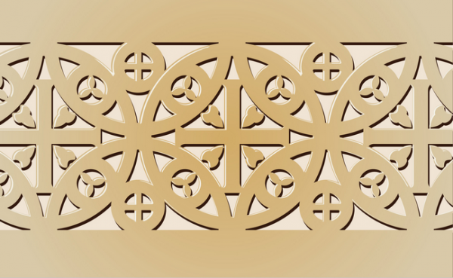
Early Europe and Colonial Americas Module

Great Mosque. Córdoba, Spain. Umayyad. c. 785–786 C.E. Stone masonry

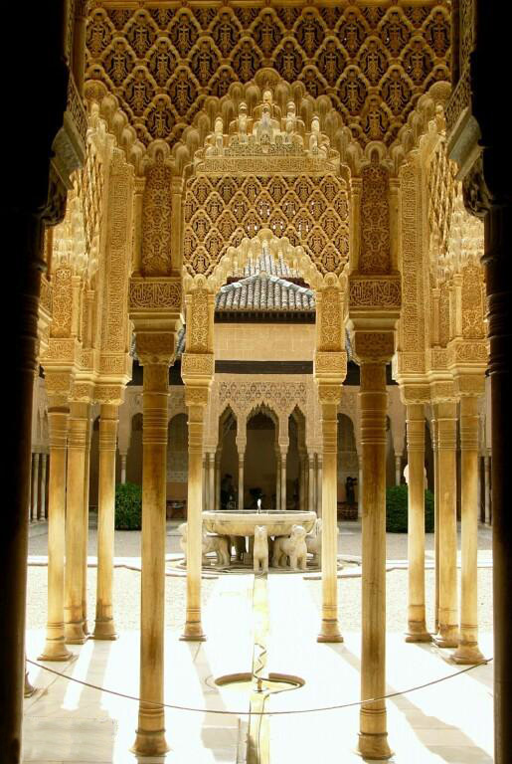
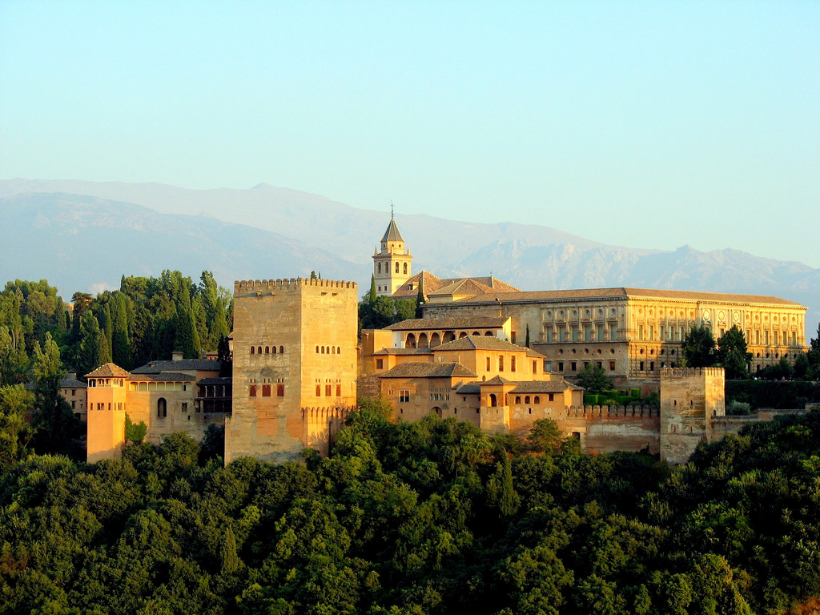

Image Citations:
"Vista de la Alhambra" by bernjan - Flickr.

http://commons.wikimedia.org/wiki/File:Vista_de_la_Alhambra.jpg#mediaviewer/File:Vista_de_la_Alhambra.jpg

The Alhambra gets its name from its reddish walls (in Arabic, it means Red Castle). It is located on top of the hill al-Sabika, to the west of the city of Granada. Created originally for military purposes, the Alhambra was an fortress, a place, and a small "medina" (city), all in one. This triple character helps to explain many distinctive features of the monument. The complex is surrounded by ramparts and has an irregular shape.
The castle of the Alhambra was added to the city's area within the ramparts in the 9th century, which implied that the castle became a military fortress. It was not until the arrival of the first king of the Nasrid dynasty, Mohammed ben Al-Hamar in the 13th century, that the royal residence was established in the Alhambra.
Yusuf I (1333-1353) and Mohammed V (1353-1391) are responsible for most of the constructions of the Alhambra that we can see today. From the improvements of the Alcazaba and the palaces, to the Patio of the Lions (Patio de los Leones) and its annexed rooms, including the extension of the area within the ramparts, the Justice Gate (Puerta de la Justicia), the extension and decoration of the towers, the building of the Baths (Baños), the Comares Room (Cuarto de Comares) and the Hall of the Boat (Sala de la Barca). The Alhambra became a Christian court in 1492 when King Ferdinand and Queen Isabel conquered the city of Granada. Later, various structures were built for prominent civilians also military garrisons, a church and a Franciscan monastery. Emperor Charles V, who spent several months in Granada, began the construction of the palace which bears his name and made some alterations to the interior buildings.
The Courtyard of the Lions is an oblong courtyard, 35 m in length by 20 m in width, surrounded by a low gallery supported on 124 white marble columns.
The courtyard layout uses the proportions of the golden ratio.
The courtyard demonstrates the complexity of Islamic geometric design – the varied columns are placed so they are symmetrical on numerous axes.
The stuccowork has a lacelike detail.
A fountain channels water through the mouths of 12 marble lions.
A pavilion has filigree walls and light domed roof, elaborately ornamented. The square is paved with colored tiles, and the colonnade with white marble; while the walls are covered 1.5 m up from the ground with blue and yellow tiles, with a border above and below enameled blue and gold.
The arches and pillars are adorned by varieties of foliage.
Above each arch there is a large square of arabesques; and over the pillars is another square of filigree work.
The Courtyard of the Lions is an oblong courtyard, 35 m in length by 20 m in width, surrounded by a low gallery supported on 124 white marble columns.
The courtyard layout uses the proportions of the golden ratio.
The courtyard demonstrates the complexity of Islamic geometric design – the varied columns are placed so they are symmetrical on numerous axes.
The stuccowork has a lacelike detail.
A fountain channels water through the mouths of 12 marble lions.
A pavilion has filigree walls and light domed roof, elaborately ornamented. The square is paved with colored tiles, and the colonnade with white marble; while the walls are covered 1.5 m up from the ground with blue and yellow tiles, with a border above and below enameled blue and gold.
The arches and pillars are adorned by varieties of foliage.
Above each arch there is a large square of arabesques; and over the pillars is another square of filigree work.

Citations:
http://en.wikipedia.org/wiki/Court_of_the_Lions

http://en.wikipedia.org/wiki/Alhambra

