Acropolis
Athens, Greece. Iktinos and Kallikrates. C. 447-424 B.C.E.
Source: https://www.internationaltraveller.com/78-trace-history-at-the-acropolis-in-athens/
During ancient times, the Athenians held a festival called "Panathenaea" which was said to rival the Olympic games. There would be a procession that moved through Athens up to the Acropolis, and into the Parthenon. As part of the ceremony, a vast robe made of woven wool would be placed on the huge ivory and gold statue of the Goddess Athena.
The Acropolis rises 490 feet into the sky above the city of Athens and has a surface area of approximately 7 acres.
The Acropolis served as the preeminent sanctuary of the ancient city of Athens. Primary purpose was to provide sacred grounds dedicated to Athena.

Parthenon, Temple of Athena Nike and the Erechteion are considered to be the three main structures of Acropolis.

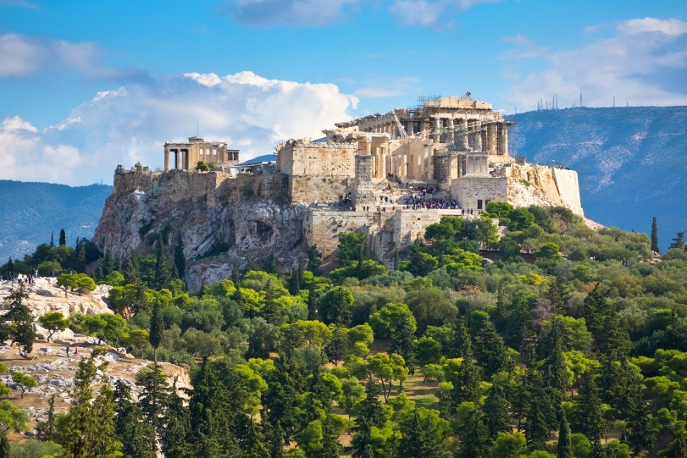
It served the purpose of both, a fortified citadel and a religious center, which houses one of the most famous buildings in the world, the Parthenon. This is why the hill of the Acropolis is called the 'Sacred Rock of Athens'.

Much of the Acropolis was destroyed by the Persians in 580 BCE but the Athenians rebuilt the city.

This structure has been in existence since the Neolithic period and provides a mesmerizing view of the sea and the land.

The Parthenon was designed by a sculptor Phidias, commissioned by Pericles, a Greek Politician. Pericles is credited with inspiring the Golden Age of Greece.

In the sixth century Christians converted the Acropolis’s temples into churches.
Originally, the Acropolis was meant for defense purposes. The Greeks kept an eye on the positions of their enemies from the complex, at the time of war.

